

Practices for Secure Software Report

Table of Contents
Document Revision History 3
Client 3
Instructions 3
Developer 4
1. Algorithm Cipher 4
2. Certificate Generation 4
3. Deploy Cipher 4
4. Secure Communications 4
5. Secondary Testing 4
6. Functional Testing 4
7. Summary 4
8. Industry Standard Best Practices 4

Document Revision History

Version | Date | Author | Comments
1.0 | October 18, 2026 | James Frost

Client



Instructions

Submit this completed practices for secure software report. Replace the bracketed text with the relevant information. You must document your process for writing secure communications and refactoring code that complies with software security testing protocols.

- Respond to the steps outlined below and include your findings.
- Respond using your own words. You may also choose to include images or supporting materials. If you include them, make certain to insert them in all the relevant locations in the document.
- Refer to the Project Two Guidelines and Rubric for more detailed instructions about each section of the template.

Developer
James Frost

Algorithm Cipher

Recommendation: For Artemis Financial, I recommend using SHA-256 to create the checksum and sending the data over HTTPS using TLS 1.2 or 1.3 with an RSA 2048-bit certificate. If the company ever needs to encrypt stored or transferred client data, I would use AES-256 in GCM mode, with the keys exchanged through TLS instead of being shared by hand.

A. Overview: SHA-256 is a hash function. It takes data of any size and turns it into a fixed 256-bit value, which is 64 hex characters. The same input always gives the same output, you can’t reverse it, and changing even one character gives a completely different result. Artemis Financial doesn’t need to hide the file, it needs to know the file wasn’t changed. So the server creates the checksum, the receiver recalculates it, and if the two don’t match, the data was changed or damaged along the way. SHA-256 is fast and has no known practical collision attacks. A hash can’t show who sent the data, so I pair it with HTTPS, where the certificate proves the server’s identity and TLS protects the connection. If Artemis later needs to prove who sent a message, an HMAC-SHA-256 could be added.

B. Hash functions and bit levels: SHA-256 makes a 256-bit digest, which gives about 128 bits of collision resistance. MD5 (128-bit) and SHA-1 (160-bit) have been broken, so they shouldn’t be used. SHA-384 and SHA-512 would also work but aren’t needed here, and SHA-3 is another good option that is built differently. The certificate uses an RSA 2048-bit key signed with SHA256withRSA, which is about 112 bits of security and the minimum that NIST and browsers accept today. AES-256 uses a 256-bit key, and GCM mode also detects tampering.

C. Random numbers and keys: Encryption is only as strong as its random numbers. Keys, TLS session keys, and IVs have to come from a secure random generator such as Java’s SecureRandom, never java.util.Random, because that one is predictable. With AES-GCM, you must never reuse an IV with the same key, so each encryption needs a new random one. Symmetric encryption like AES uses one shared secret key to both encrypt and decrypt. It’s fast, so it’s good for large amounts of data, but both sides need the key and sharing it safely is hard. Asymmetric encryption like RSA uses a public key and a private key. The public key can be given to anyone and the private key stays on the server. It’s slower, so TLS uses it to verify the server and set up a shared session key, and then switches to symmetric encryption. A hash doesn’t use a key at all. In this project the private key is stored in a password-protected keystore, and in a real deployment the password would come from an environment variable or secrets manager instead of the source code.

D. History and current state: DES, from 1977, used a 56-bit key and became too easy to brute force. It was replaced first by Triple DES and then by AES, which NIST chose in 2001. For hashing, MD5 (1991) and SHA-1 (1995) were popular until researchers found practical collision attacks (MD5 in 2004, SHA-1 in 2017). SHA-2 came out in 2001 and is still the standard, and SHA-3 was added in 2015 as a backup. RSA and Diffie-Hellman, both from the 1970s, started public-key cryptography. SSL and early TLS versions (1.0 and 1.1) are now deprecated, and TLS 1.2 and 1.3 are what’s used today. Current best practice is AES-GCM or ChaCha20-Poly1305 for encryption, SHA-256 or better for hashing, RSA 2048+ or ECDSA for certificates, and TLS 1.2 or higher. NIST is also working on post-quantum algorithms, since quantum computers could eventually break RSA and elliptic curves, so Artemis should plan to be able to switch algorithms later.

Certificate Generation
I used the Java keytool to make a self-signed certificate. It’s stored in a PKCS12 keystore, uses an RSA 2048-bit key signed with SHA256withRSA, and is valid for 365 days. I added localhost to the subject alternative name so the browser matches it to the server address. This is the command I ran:

keytool -genkeypair -alias artemis -keyalg RSA -keysize 2048 -sigalg SHA256withRSA -validity 365 -storetype PKCS12 -keystore keystore.p12 -storepass changeit -keypass changeit -dname "CN=localhost, OU=Engineering, O=Global Rain, L=Chicago, ST=IL, C=US" -ext "SAN=dns:localhost,ip:127.0.0.1"

Then I exported the certificate to a CER file with this command:

keytool -exportcert -alias artemis -keystore keystore.p12 -storepass changeit -file artemis.cer -rfc

Both keystore.p12 and artemis.cer are in the src/main/resources folder of the project. The screenshot below shows the contents of the CER file.

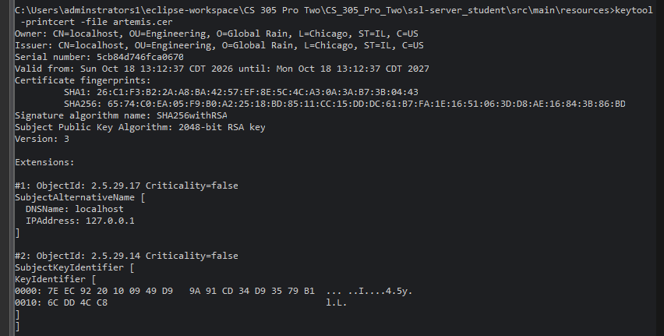

Deploy Cipher
To add the checksum, I created a new class called ChecksumController. It is a Spring @RestController with a GET route at /hash. When the route is called, it takes a fixed string that includes my name, converts it to UTF-8 bytes, and runs it through SHA-256 using Java’s MessageDigest class. The result is converted to hex and returned as plain text, along with the original data and the name of the algorithm. This lets anyone who gets the data recalculate the hash and compare it to confirm nothing was changed.

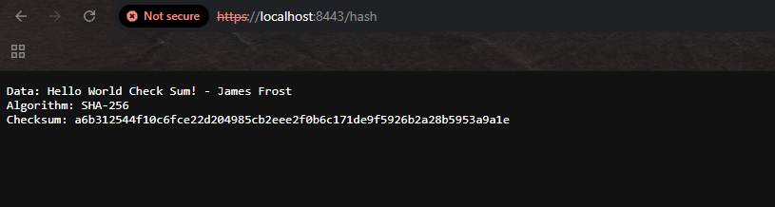

Secure Communications
To switch the application from HTTP to HTTPS, I filled in the placeholder values in application.properties. I set the port to 8443, the key alias to artemis, the keystore to keystore.p12, and the keystore type to PKCS12. The keystore password is read from an environment variable named KEYSTORE_PASSWORD, with the development password as the default so the project still runs in Eclipse. I also turned SSL on and limited the allowed protocols to TLS 1.2 and 1.3 so older, weaker versions can’t be used. After running the application, I went to https://localhost:8443/hash in the browser. The browser shows a warning because the certificate is self-signed and not from a trusted authority, so I clicked through it. The page still loads over HTTPS, as the screenshot below shows.

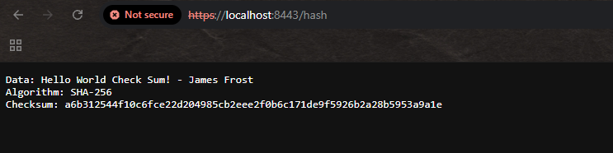

Secondary Testing
After running the OWASP dependency-check on the refactored project, I looked through the report. The first scan found 99 known vulnerabilities in 7 of the 46 dependencies, and the most serious ones were Critical findings in spring-boot, spring-core, and tomcat-embed-core. These all came from the old libraries that came with the project and not from my code. To fix this, I upgraded the Spring Boot parent version in the pom.xml from 2.2.4 (from 2020) to 4.1.1, set the Java version to 17, and updated the dependency-check plugin to 13.0.0 because the old version can’t read the current vulnerability database.

I ran the scan again after the upgrade. This time it scanned 56 dependencies (27 unique) and found 13 vulnerabilities in 2 of them. The first is spring-boot-data-rest 4.1.1, with 2 High findings. The second is tomcat-embed-core 11.0.24, with 11 findings, the most serious rated Critical. Both of these libraries came with the Spring Boot starters that were already in the pom.xml. The code I added only uses classes from the JDK (java.security and java.nio) and Spring annotations that were already in the project, so my refactoring did not introduce any new vulnerabilities.

For the remaining findings, my next step would be to check whether a newer Tomcat patch is available and update it in the pom.xml, then run the dependency-check again. I would also look at each of the spring-boot-data-rest findings, because dependency-check sometimes matches a library to the wrong product by its name and version, which makes a false positive. Since the application is not yet in production, I would resolve or document these before release.

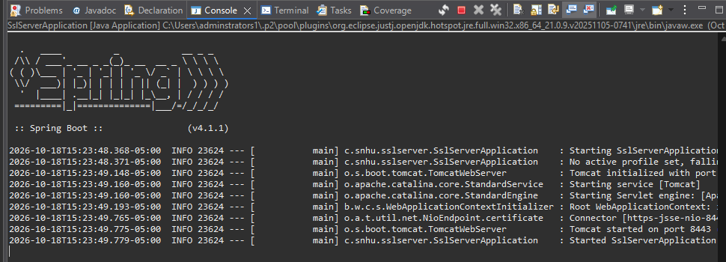

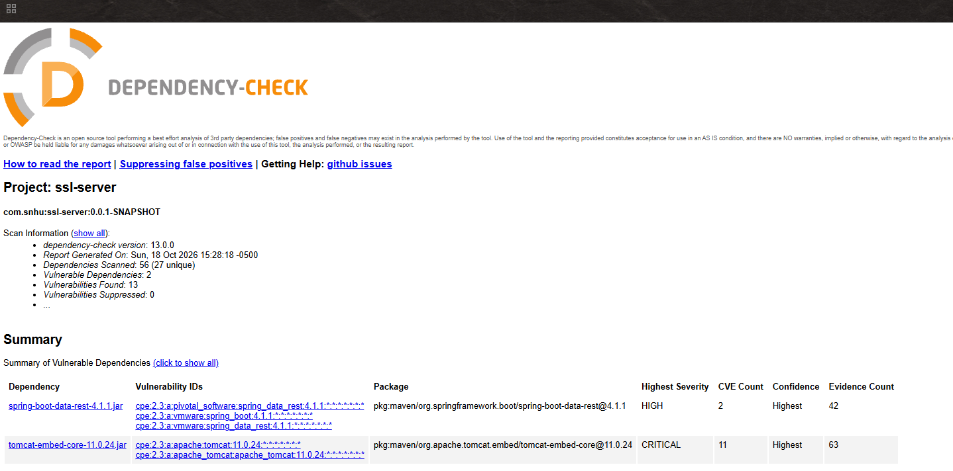

Functional Testing
I went through the code by hand and checked for three kinds of problems.

Syntactic: The code compiles and runs on Java 17 with no errors. The original skeleton had an unfinished FIXME comment and “????” placeholders in application.properties, and the placeholders would have kept the server from starting, so I replaced them.

Logical: The hash is calculated from UTF-8 bytes, so the result is the same on any computer. When I convert the bytes to hex, each byte is padded to two digits, so a byte like 0x0a doesn’t lose its leading zero and give a wrong checksum. I create a new MessageDigest for every request because those objects aren’t thread-safe.

Security: The endpoint only hashes a fixed string, so there’s no user input and nothing to inject or traverse. It’s a read-only GET request. The server only listens on port 8443 with TLS, and older protocols are turned off. The keystore password comes from an environment variable instead of being hardcoded. For a real production system I would also use a certificate from a trusted authority instead of a self-signed one, store secrets in a secrets manager, add security headers like HSTS, and add Spring Security if any endpoints needed to be private.

The screenshot below shows the refactored code running without errors.

Summary

I made three main changes to Artemis Financial’s application. First, I added a ChecksumController that has a /hash route and returns a SHA-256 checksum so data can be verified. Second, I replaced the placeholder SSL settings in application.properties so the server runs only over HTTPS on port 8443, using a PKCS12 keystore with a self-signed RSA 2048-bit certificate. Third, I limited the server to TLS 1.2 and 1.3, moved the keystore password into an environment variable, and upgraded Spring Boot to 4.1.1 to reduce known vulnerabilities in the old libraries.

A. Looking at the vulnerability assessment flow diagram, these are the areas I covered. For input validation, the new endpoint doesn’t accept any user input. For cryptography, I used SHA-256 for integrity and an RSA 2048 certificate. For secure communication, HTTPS replaces plain HTTP, so data is protected while it moves. For dependencies, I ran dependency-check and upgraded the old Spring Boot version. Code quality and error handling were covered with my manual review in the Functional Testing section.

B. I added security in layers and tested after each one so I would know which change caused a problem. First I picked the algorithm based on the requirements. Then I made the certificate and keystore, turned on TLS in the configuration, and added the checksum code. Last, I ran the dependency-check scan and reviewed the code by hand. Each layer covers something different: TLS protects the data and proves the server’s identity, the checksum shows if data was changed, and the testing finds weak spots I might have added. If any step turned up a problem, I fixed it and ran the tests again until nothing new showed up.

Industry Standard Best Practices

A. Maintaining existing security. While making my changes, I followed well-known secure coding standards like the OWASP Secure Coding Practices and the CERT Java guidelines. I used Java’s built-in tools for the cryptography (MessageDigest, keytool, and JSSE) instead of trying to write my own, since homemade encryption is usually where mistakes happen. I picked current algorithms like SHA-256 and TLS 1.2/1.3, and I turned off the older, weaker ones. I also kept the application as small as possible, with only one read-only endpoint and one HTTPS port, so there’s less for an attacker to target. The keystore password comes from an environment variable and isn’t hardcoded in the source. I didn’t change the way the existing Spring Boot project was set up, so what already worked and was already protected stayed the same. I also scanned the dependencies for known vulnerabilities and upgraded the old Spring Boot version, which covers OWASP’s “vulnerable and outdated components” risk.

B. Value to the company. Artemis Financial works with people’s savings, retirement, investment, and insurance information, so a data breach would hurt its customers directly. It could also lead to fines, legal costs, and the loss of customer trust, which a financial consulting company depends on. Following secure coding practices lowers the chance of a breach, and it’s much cheaper to fix problems while the software is being built than after it’s released. Encrypted connections and integrity checks also help the company meet privacy rules for financial data, such as GLBA. They show clients that Artemis takes their information seriously, which can make the company stand out from competitors. This also fits Global Rain’s belief that security is everyone’s responsibility.

